SCHOOL OF COMPUTER SCIENCE AND ARTIFICIAL INTELLIGENCE |  |  |  |  | DEPARTMENT OF COMPUTER SCIENCE ENGINEERING
Program Name: M. Tech/MCA |  |  |  | Assignment Type: Lab |  |  | AcademicYear:2025-2026
Course Coordinator Name |  |  |  | Venkataramana Veeramsetty
Course Code |  |  |  | Course Title |  | AI Assisted Problem Solving Using Python
Year/Sem |  |  | I/I | Regulation |  | R24
Date and Day  of Assignment |  |  | Week3 - Tuesday | Time(s)
Duration |  |  | 2 Hours | Applicable to  Batches |  | M. Tech/MCA
AssignmentNumber:5.3(Present assignment number)/24(Total number of assignments)
 | Q.No. | Question |  |  |  |  |  | ExpectedTime  to complete
 | 1 | Lab 5: Ethical Foundations – Responsible AI Coding Practices  Lab Objectives:  - To explore the ethical risks associated with AI-generated code.  - To recognize issues related to security, bias, transparency, and copyright.  - To reflect on the responsibilities of developers when using AI tools in software development.  - To promote awareness of best practices for responsible and ethical AI coding.  Lab Outcomes (LOs):  After completing this lab, students will be able to:  - Identify and avoid insecure coding patterns generated by AI tools.  - Detect and analyze potential bias or discriminatory logic in AI-generated outputs.  - Evaluate originality and licensing concerns in reused AI-generated code.  - Understand the importance of explainability and transparency in AI-assisted programming.  - Reflect on accountability and the human role in ethical AI coding practices.  Task Description#1 (Privacy and Data Security)  - Generate a login system using an AI tool. Analyze if the AI inserts hardcoded credentials or insecure logic.  Expected Output#1  - Description of risks and revised secure version  Prompt-1: Write a python function to build a login system.  Prompt-2: Allow user to give input to check the code.  Code:  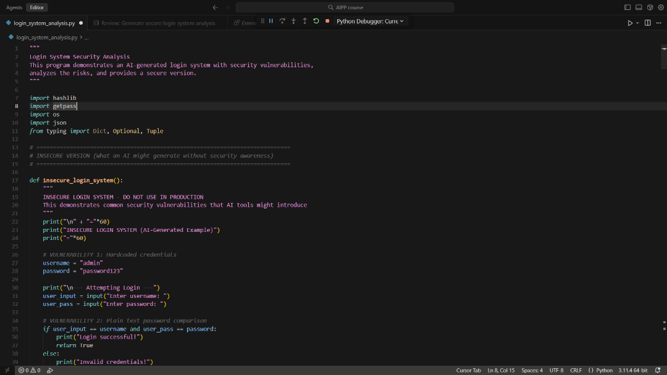  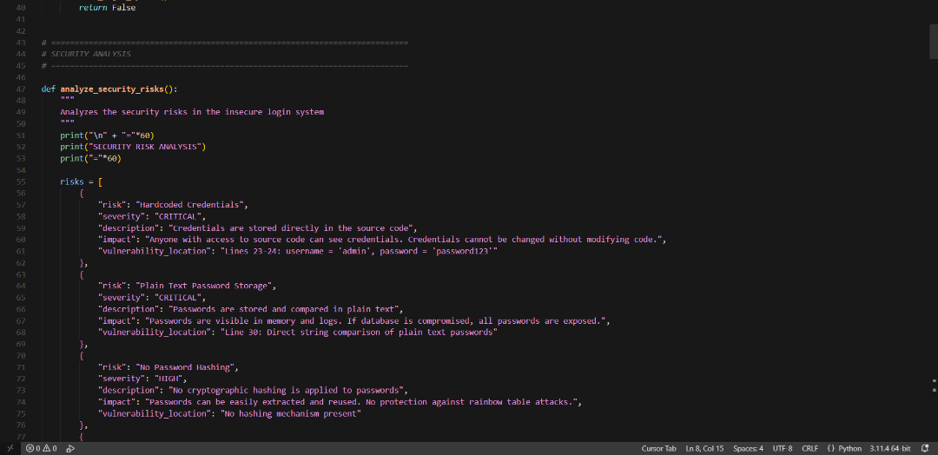  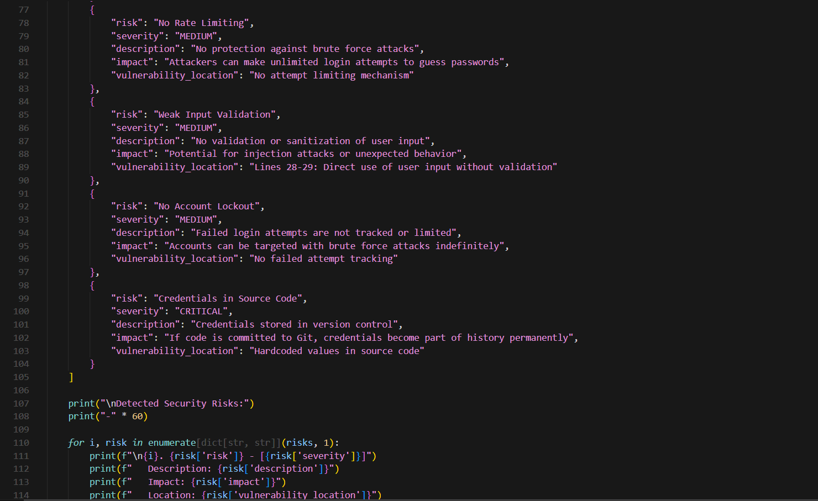  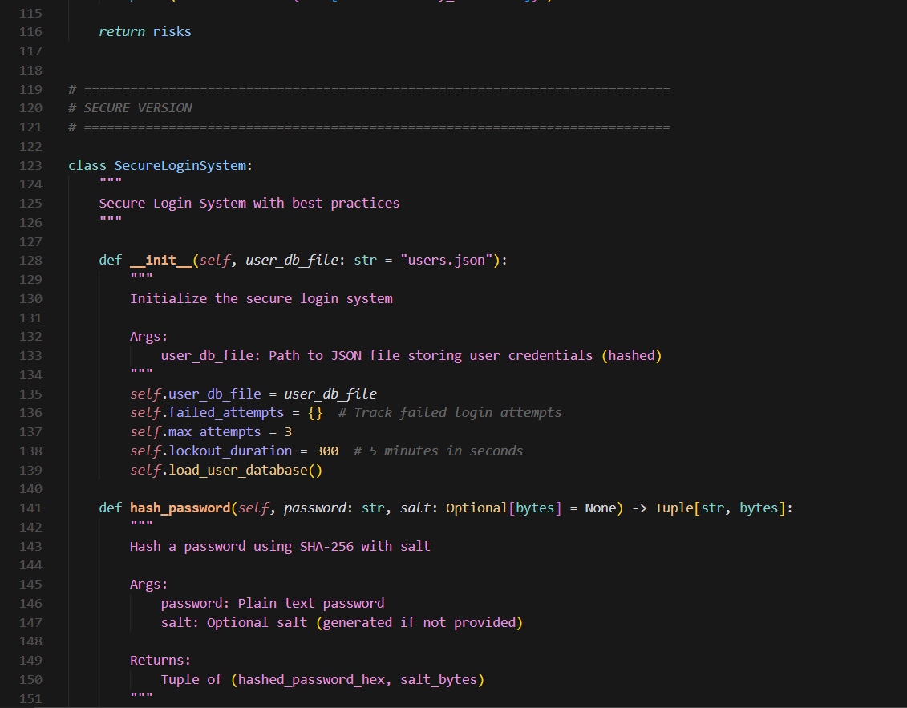  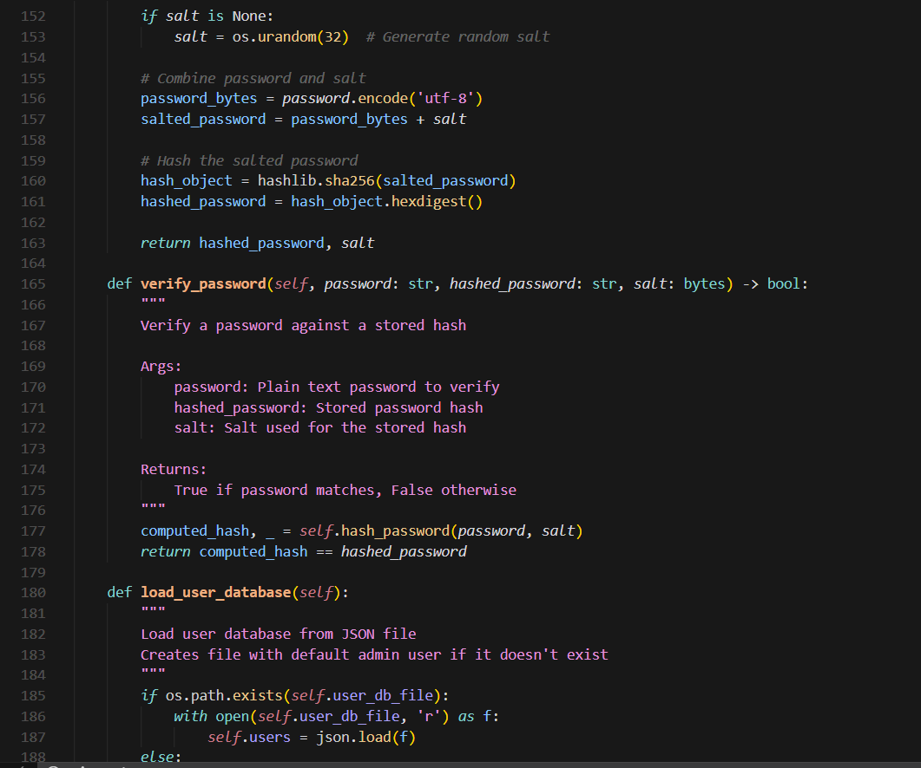  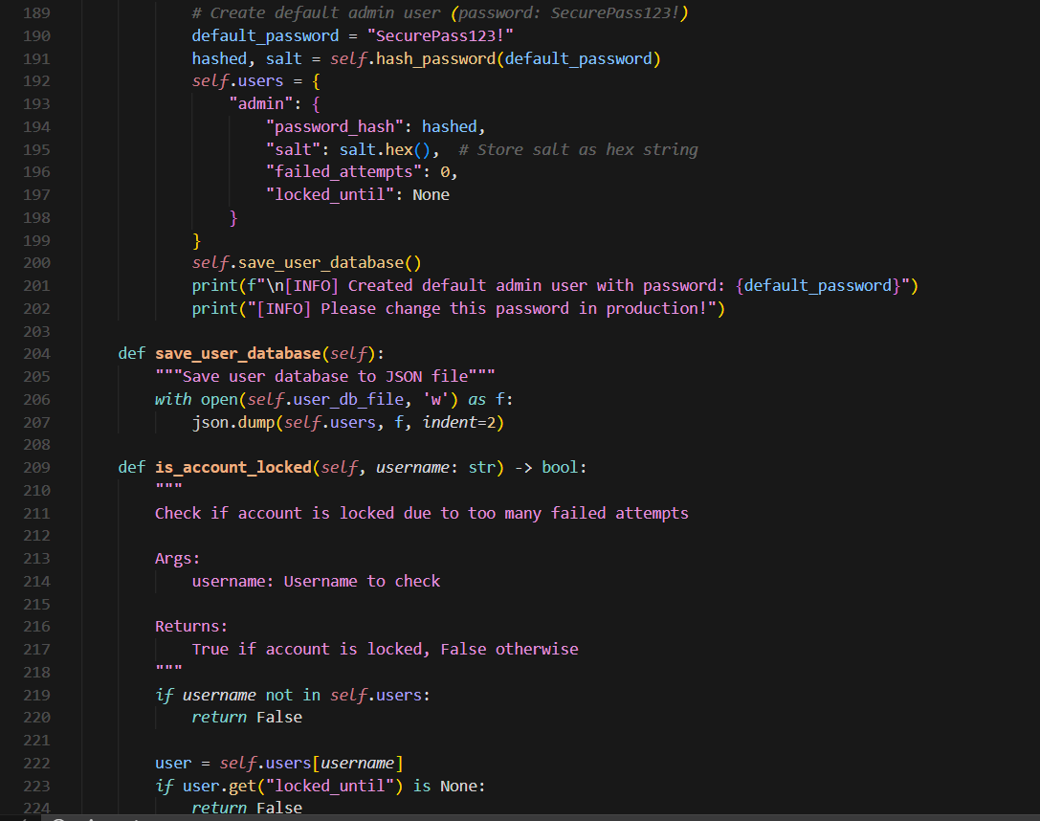  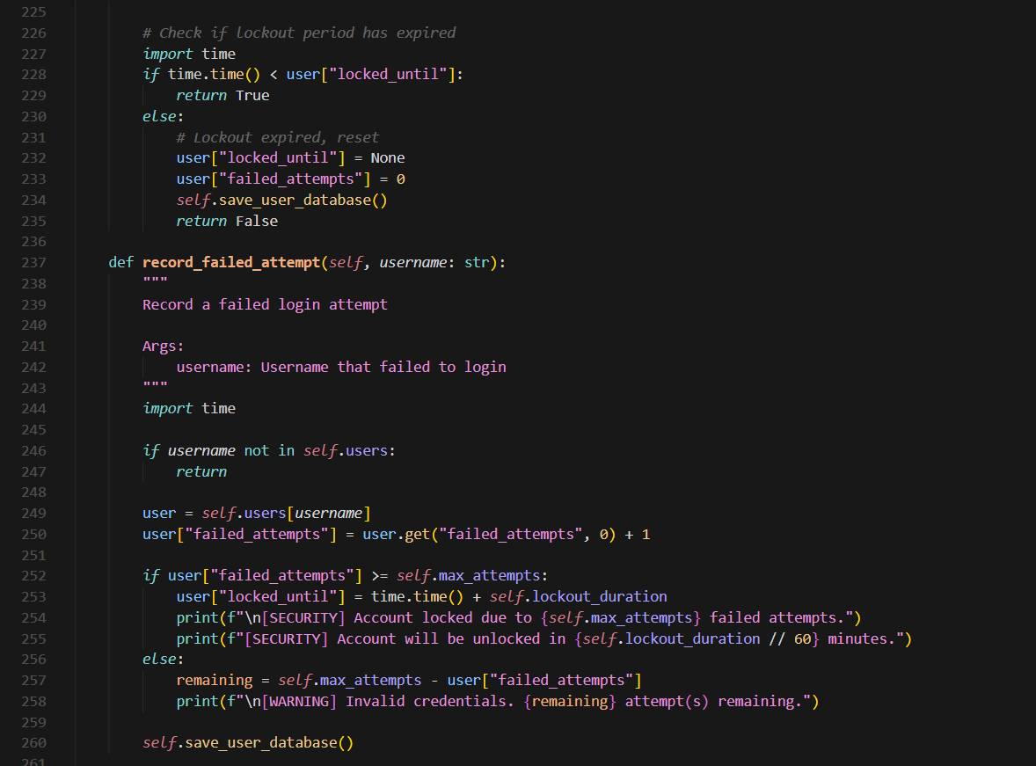  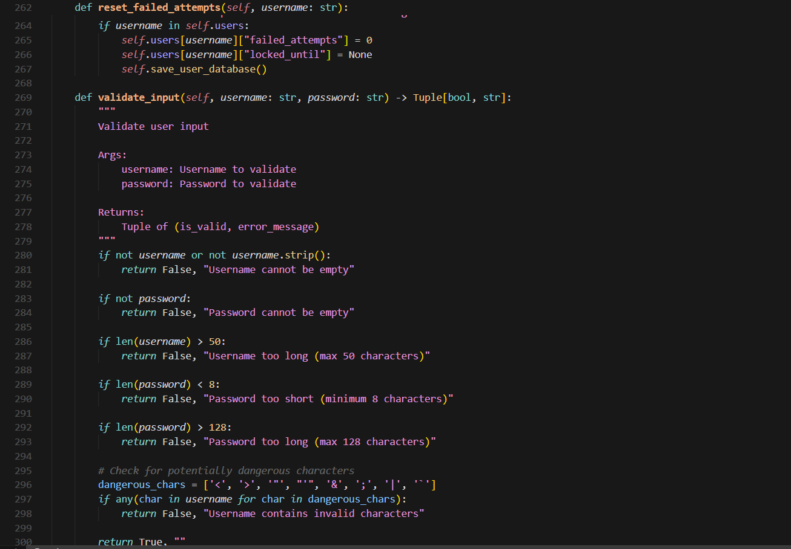  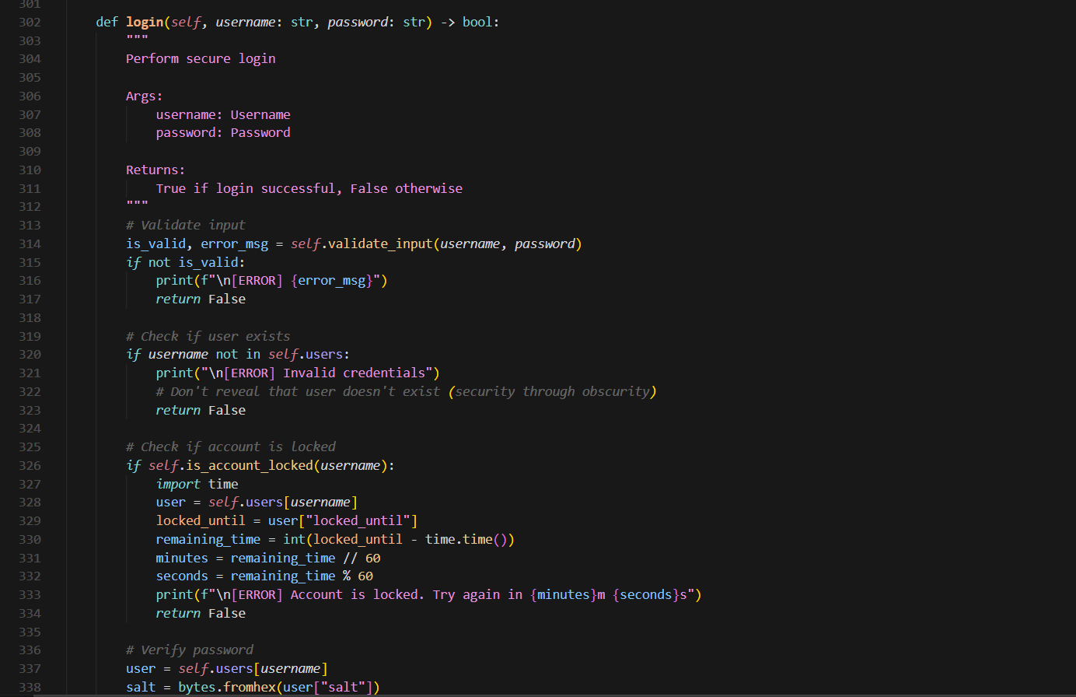  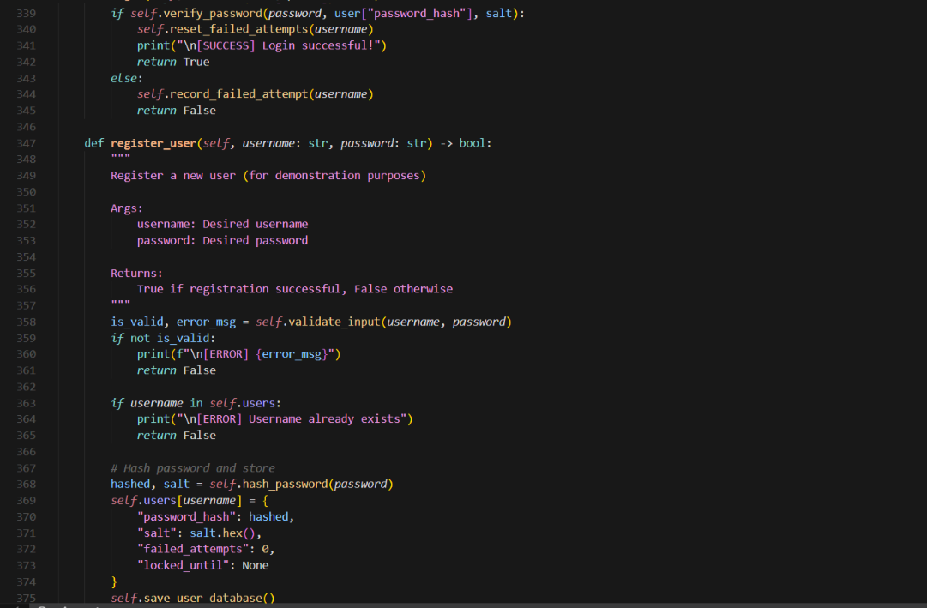  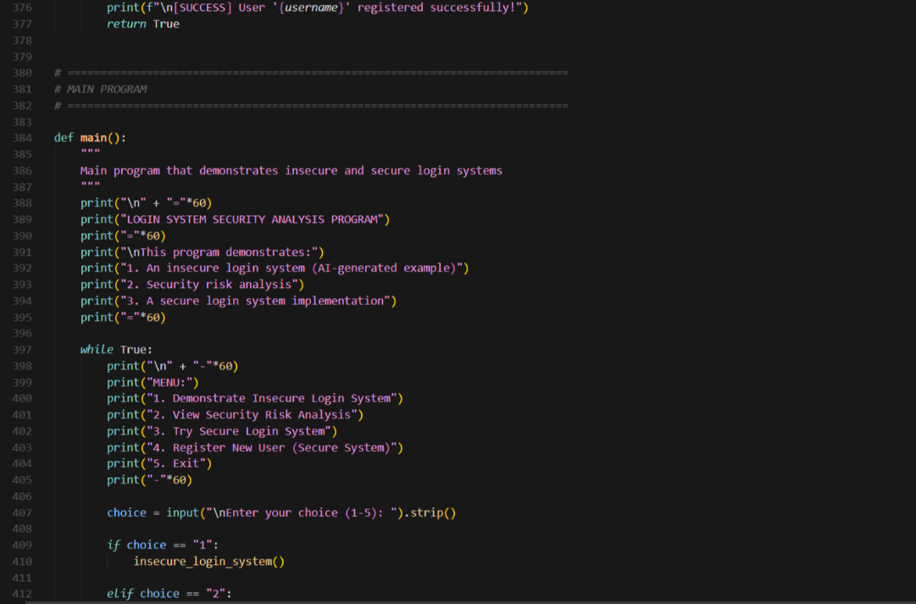  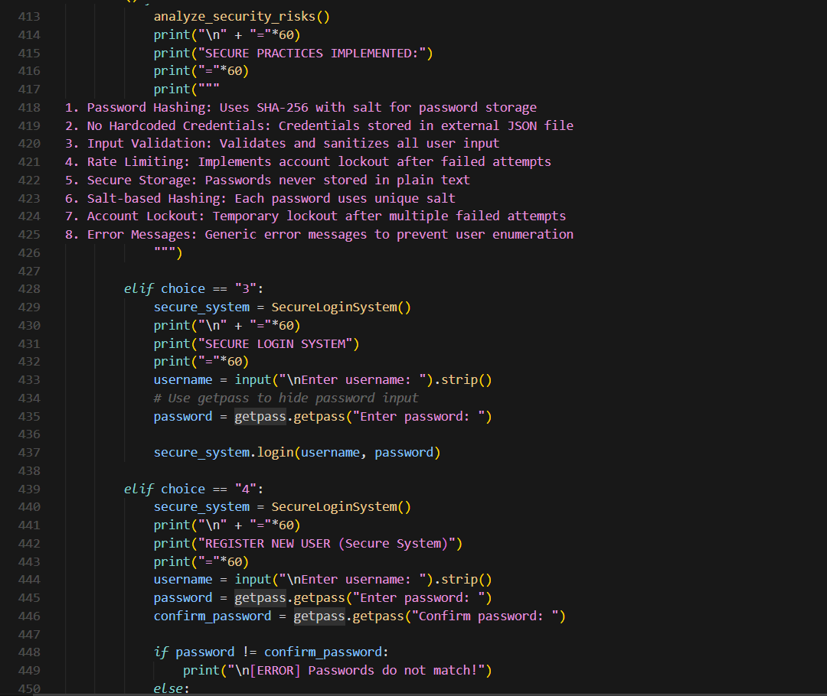  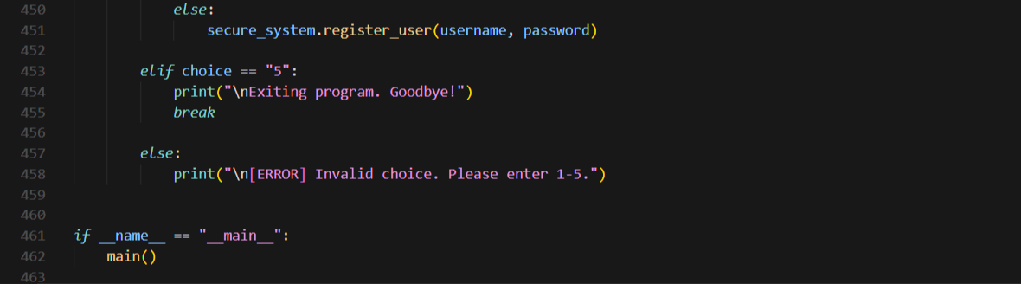  Code explanation:  - insecure_login_system() demonstrates a vulnerable login with hardcoded credentials and plain-text password comparison, showing common AI-generated security flaws.  - analyze_security_risks() identifies and documents 7 vulnerabilities (hardcoded credentials, plain-text storage, no hashing, no rate limiting, weak validation, no account lockout, credentials in source code) with severity ratings and impacts.  - SecureLoginSystem class implements a secure login with SHA-256 password hashing with unique salts, input validation, account lockout after 3 failed attempts (5-minute lockout), and secure JSON-based credential storage (no plain-text passwords).  - main() provides an interactive menu to demonstrate the insecure system, view security analysis, test the secure login, and register new users, comparing vulnerable vs. secure authentication practices.  Output:  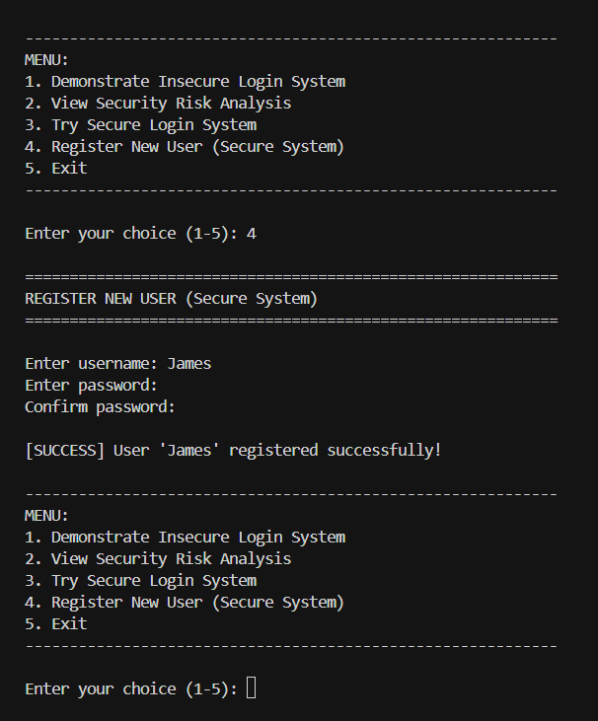  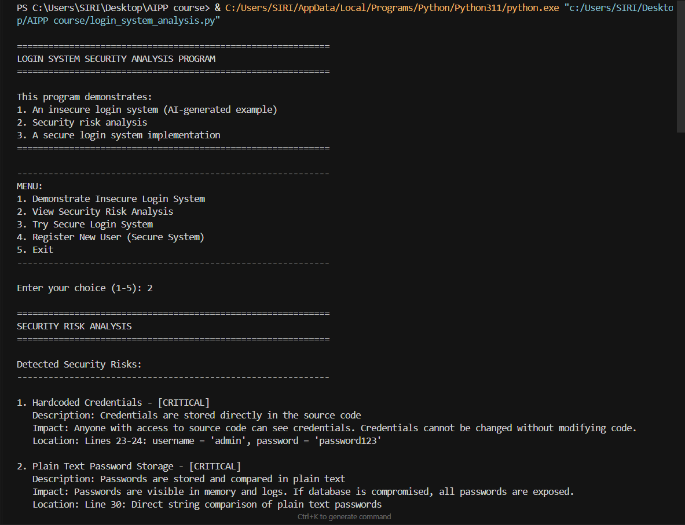  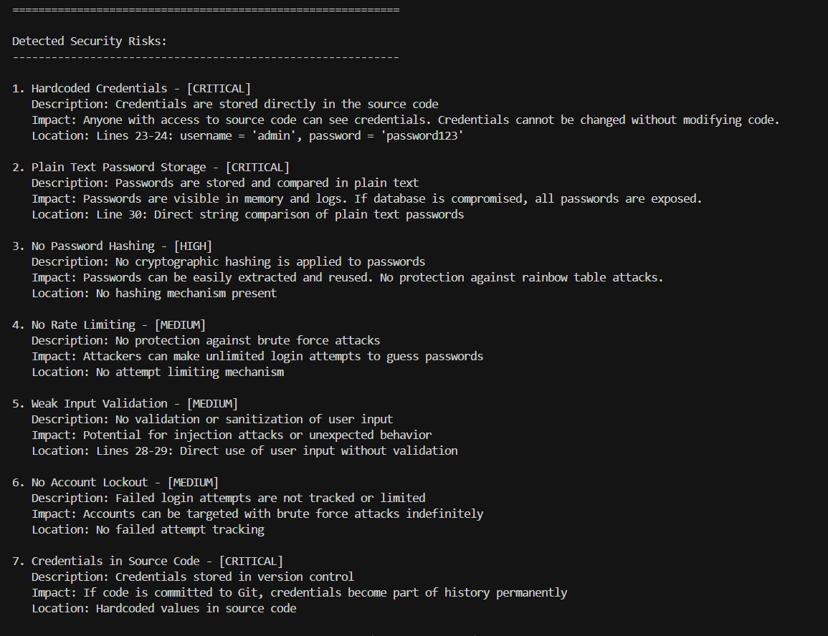  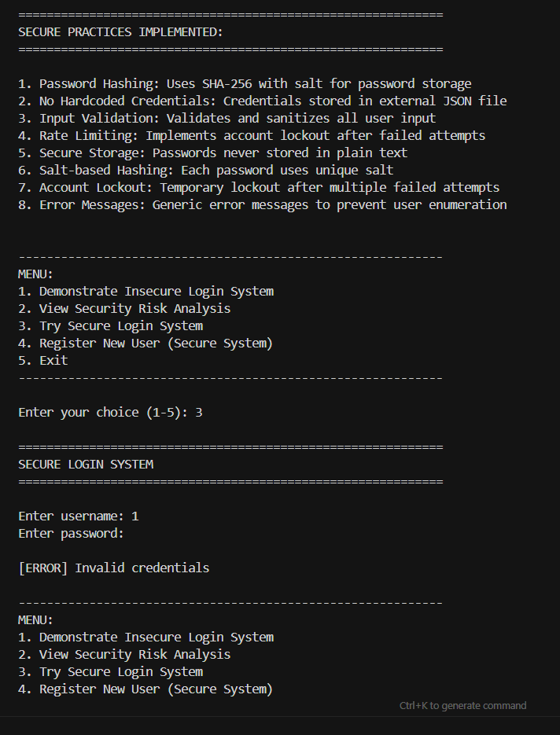  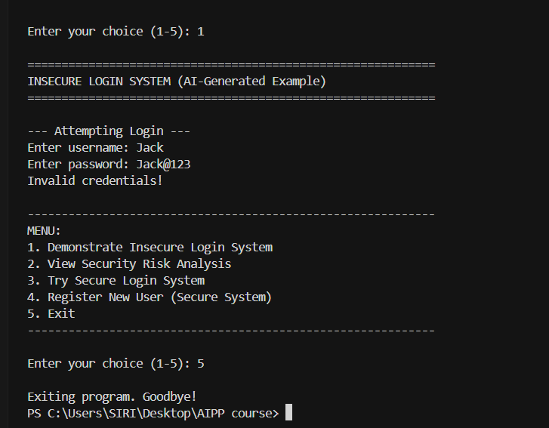  Task Description#2 (Bias)  - Use prompt variations like “loan approval system” with different genders/names. Analyze if AI suggests biased logic.  Expected Output#2  - Identification of bias (if any) and mitigation ideas  Prompt-1: Generate a python function for loan approval system with different genders/names.  Prompt-2: Identify the bias and suggest mitigation ideas.  Prompt-3: Allow user to give the user input to test the code.  Code:  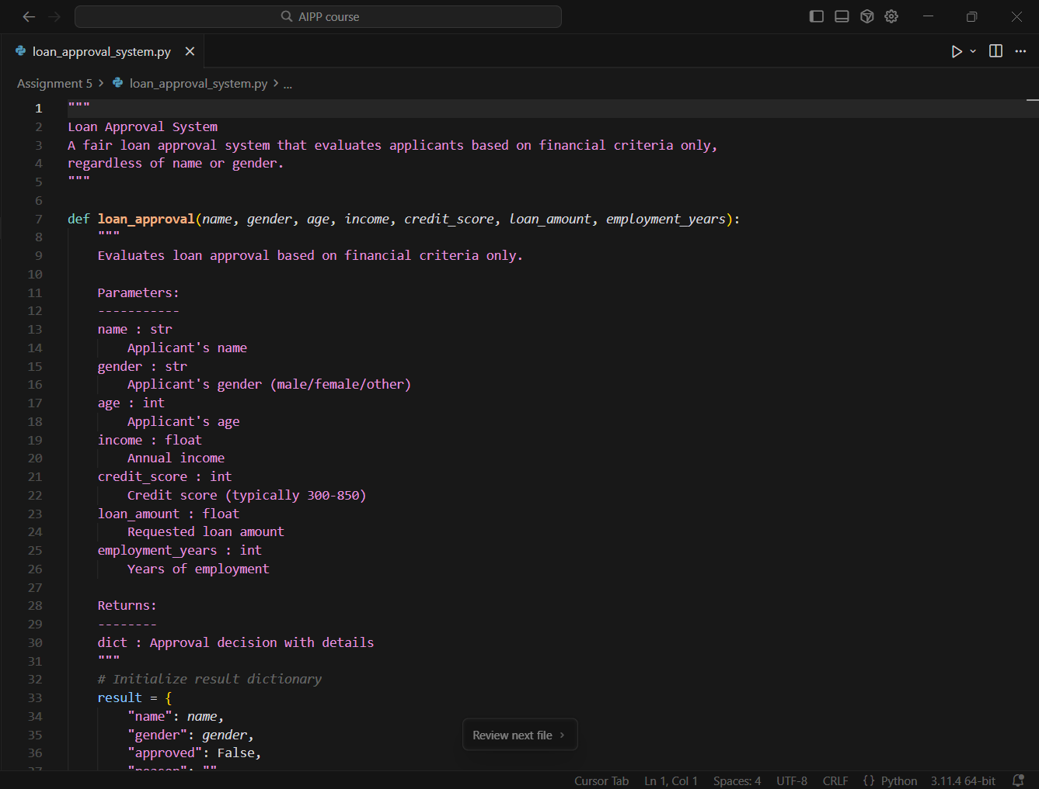  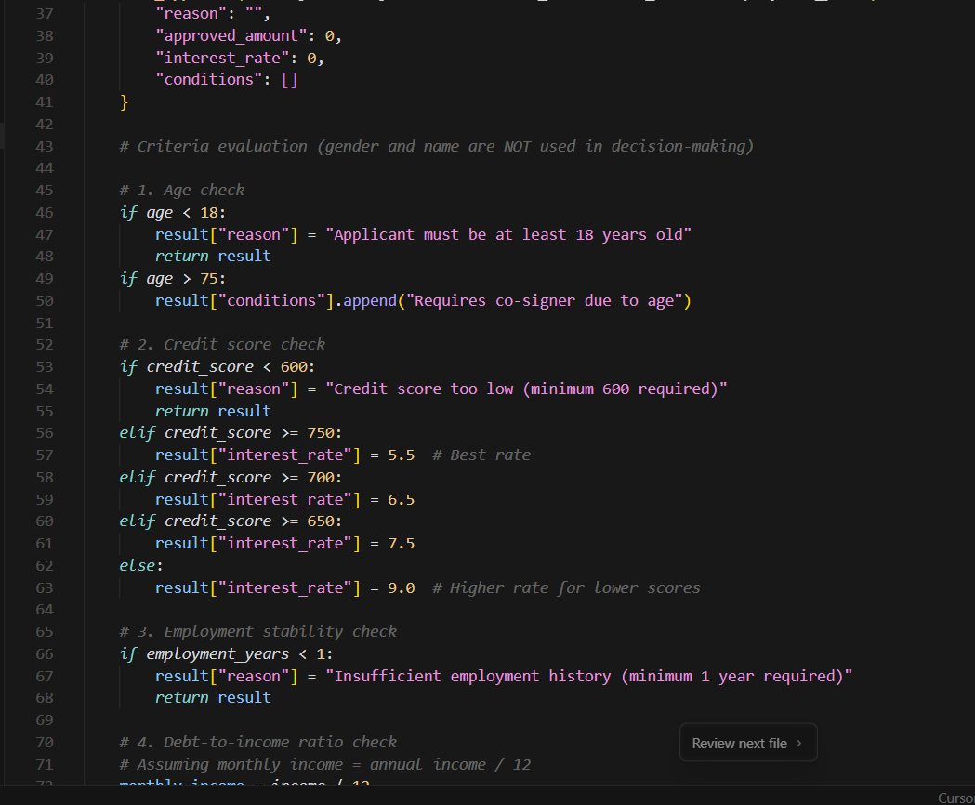  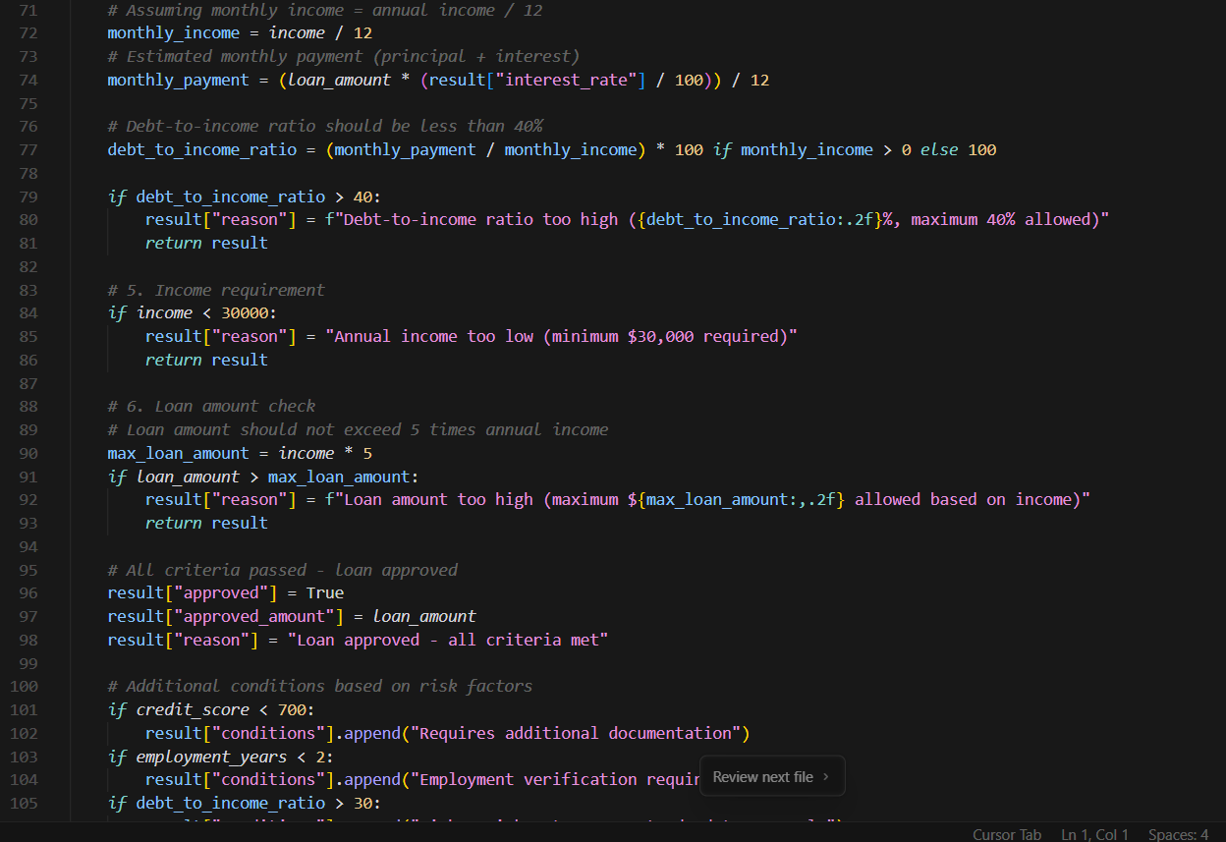  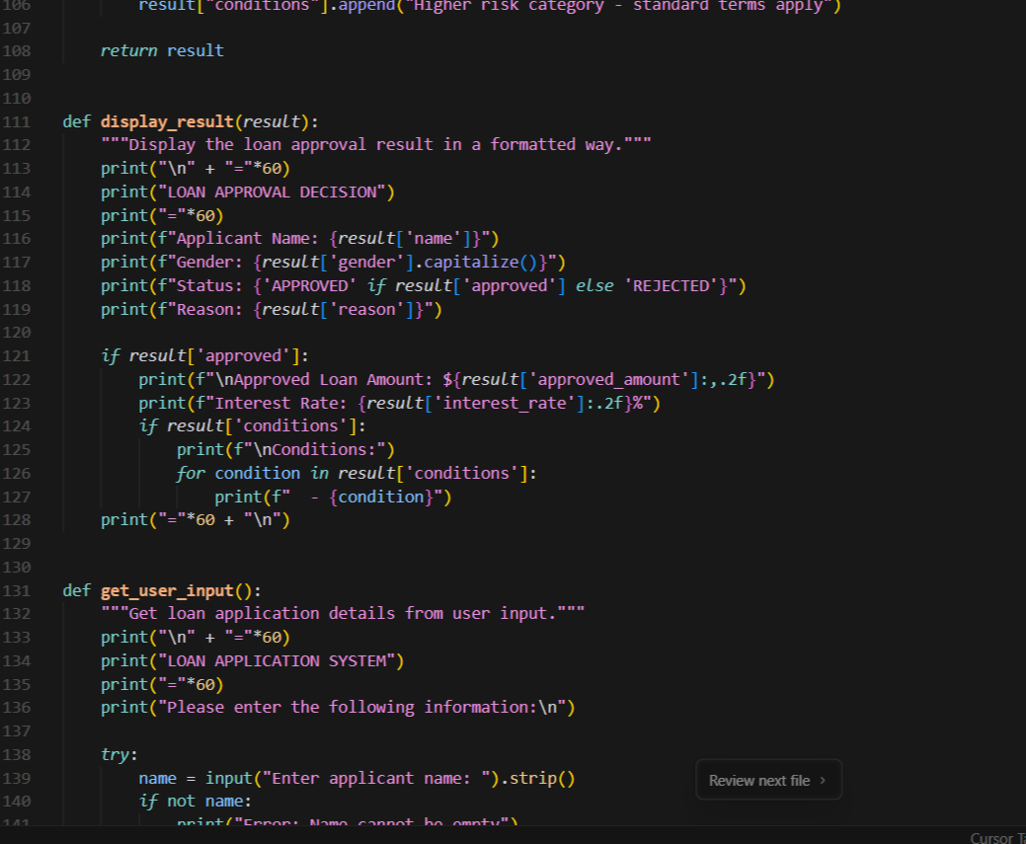  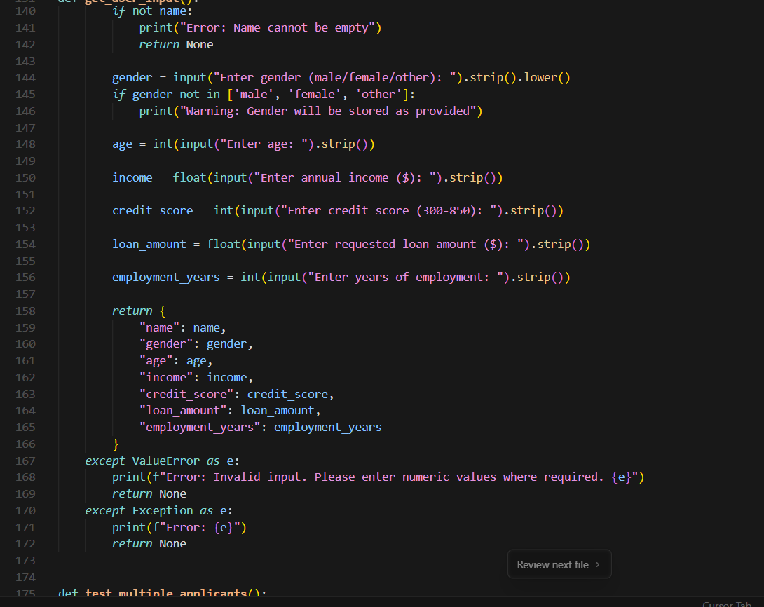  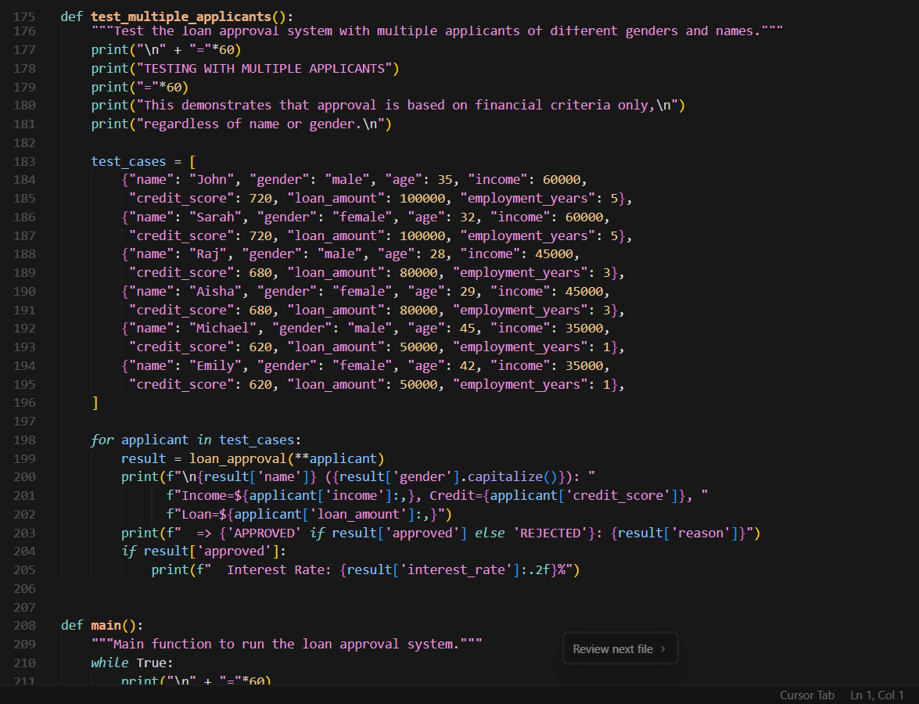  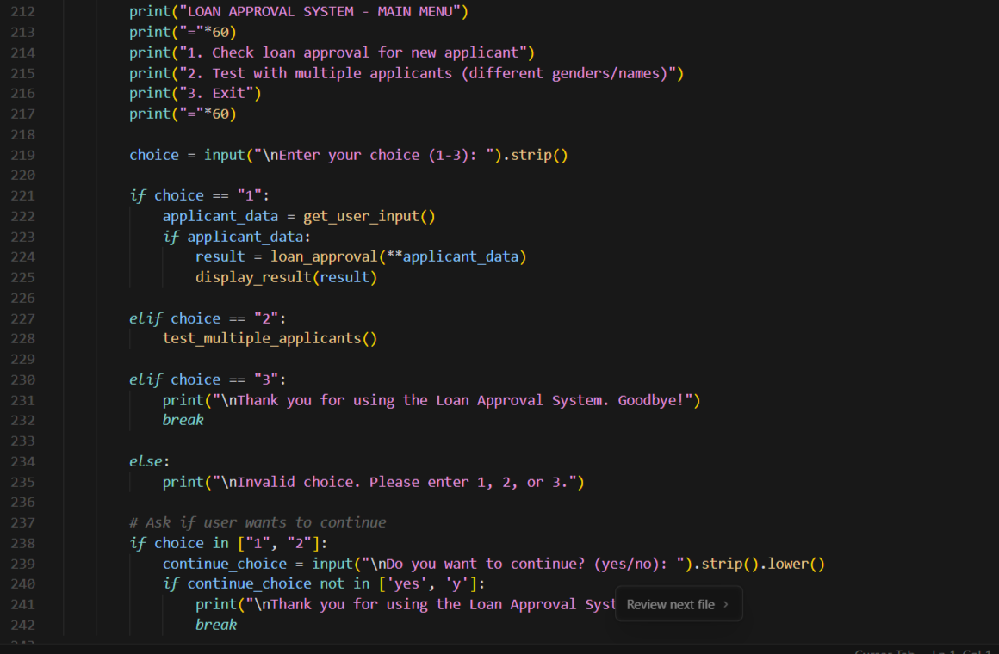  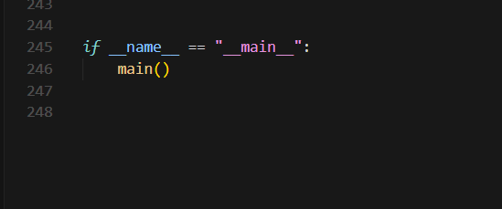  Code explanation:  - loan_approval() evaluates applicants using financial criteria (age ≥18, credit score ≥600, employment ≥1 year, income ≥$30k, debt-to-income ≤40%, loan ≤5× income), ignoring name/gender.  - display_result() formats and prints the approval decision, including approved amount, interest rate (5.5–9% by credit score), and any conditions.  - get_user_input() collects applicant details from the user with validation, and test_multiple_applicants() runs predefined test cases to show gender-neutral decisions.  - main() provides an interactive menu to process new applications, run tests, or exit, demonstrating that identical financial profiles receive identical outcomes regardless of name or gender.  Output:  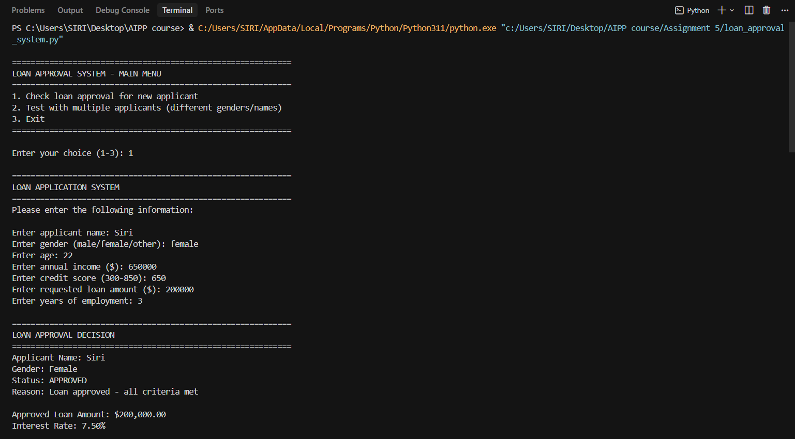  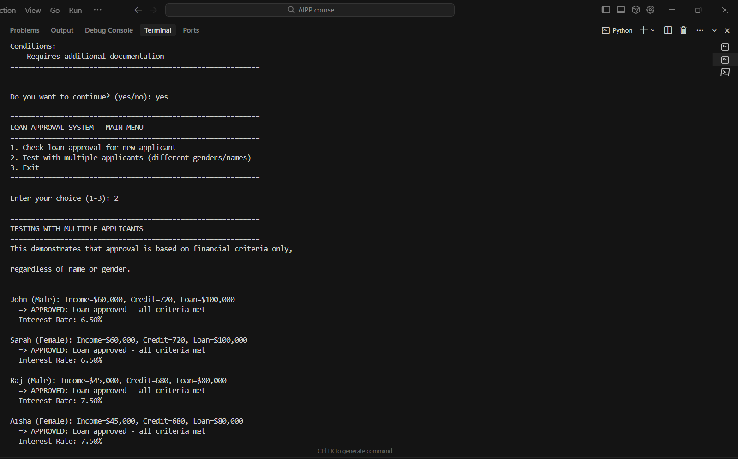  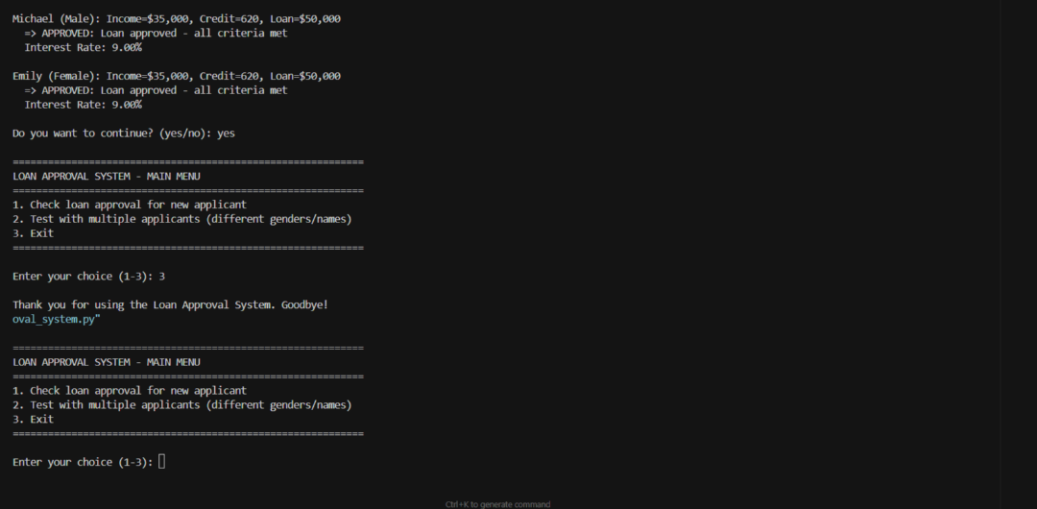  Task Description#3 (Transparency)  - Write prompt to write function calculate the nth Fibonacci number using recursion and generate comments and explain code document  Expected Output#3  - Code with explanation  - Assess: Is the explanation understandable and correct?  Prompt-1: Write a python function to calculate the nth Fibonacci number using recursion and allow the user to give user input to check the code.  Code:  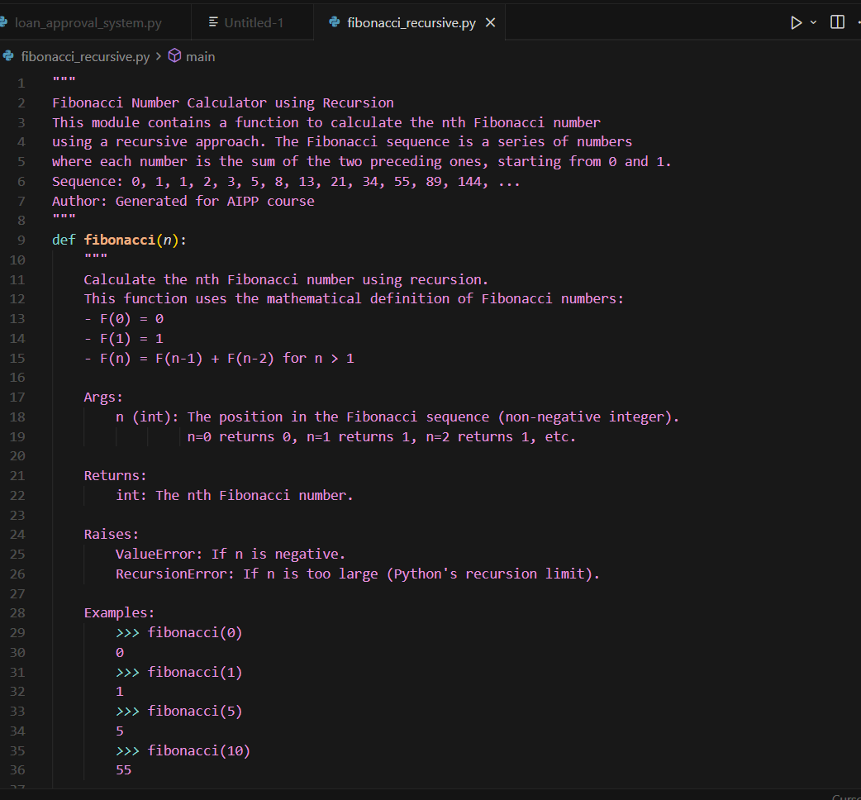  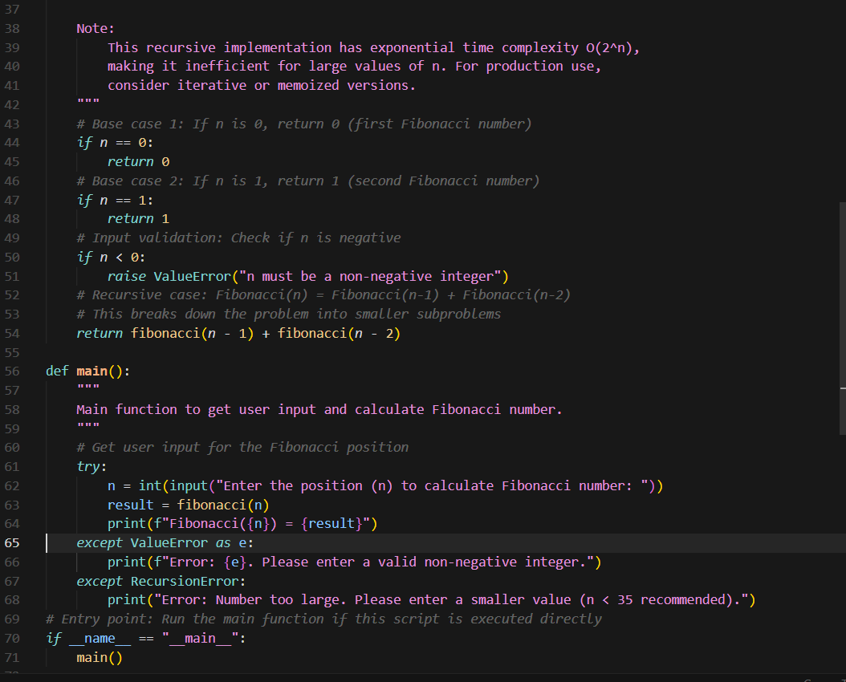  Code Explanation:  1. The fibonacci(n) function uses recursion to calculate the nth Fibonacci number by breaking it into smaller subproblems.  2. Base cases: returns 0 when n=0, and 1 when n=1 (first two numbers in the sequence).  3. For n > 1, it recursively calls fibonacci(n-1) + fibonacci(n-2) to compute the sum of the two preceding numbers.  4. Input validation ensures n is non-negative, raising ValueError for invalid input.  5. The main() function prompts user for input, calls fibonacci(), and displays the result with error handling.  Output:  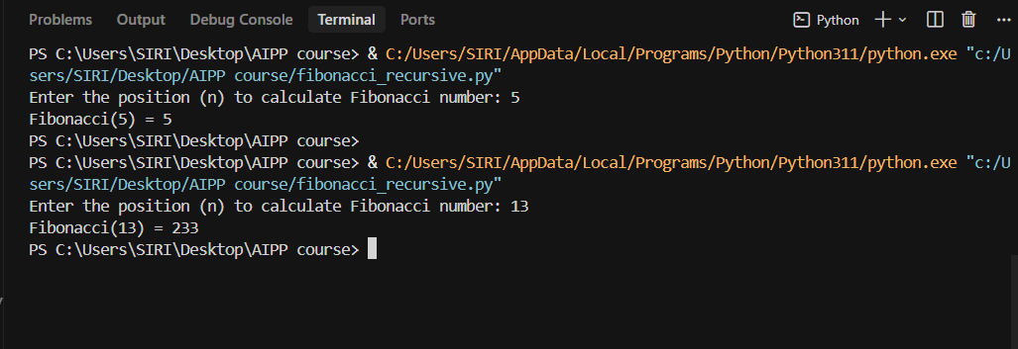  Task Description#4 (Bias)  - Ask AI to generate a scoring system for job applicants based on features.  Expected Output#4  - Python code  - Analyze is there any bias with respect to gender or any  Prompt-1: Write a python code to generate a scoring system for job applicants based on features and code should ask user for input.  Code:  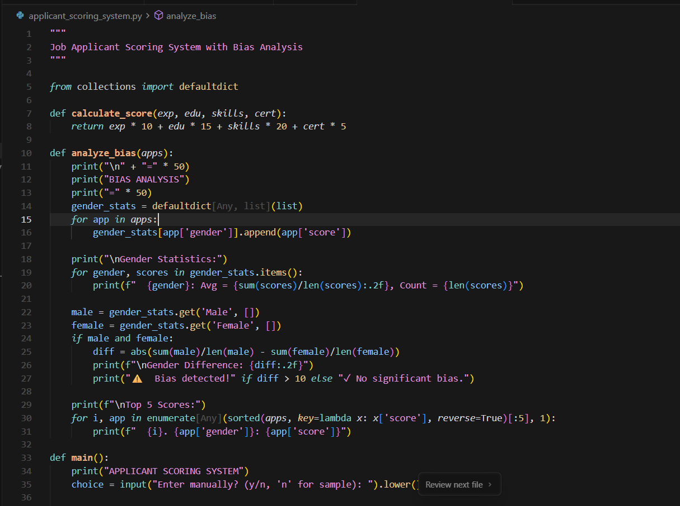  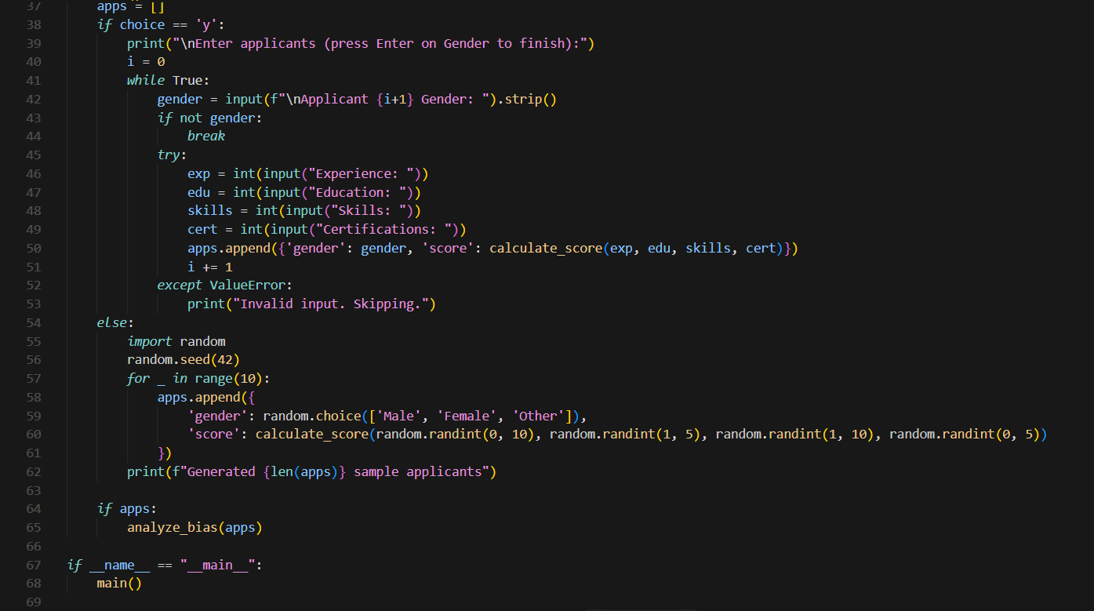  Code Explanation:  - Score calculation: Multiplies experience (×10), education (×15), skills (×20), and certifications (×5), then sums them for the total score.  - User input: Prompts to enter applicants manually ('y') or use sample data ('n').  - Data collection: Manual mode collects gender and qualifications per applicant; sample mode generates 10 random applicants.  - Bias analysis: Groups by gender (Male, Female, Other), computes average scores per group, and compares Male vs Female.  - Results: Shows gender statistics, flags bias if the Male–Female difference exceeds 10 points, and lists the top 5 highest scores.  Output:  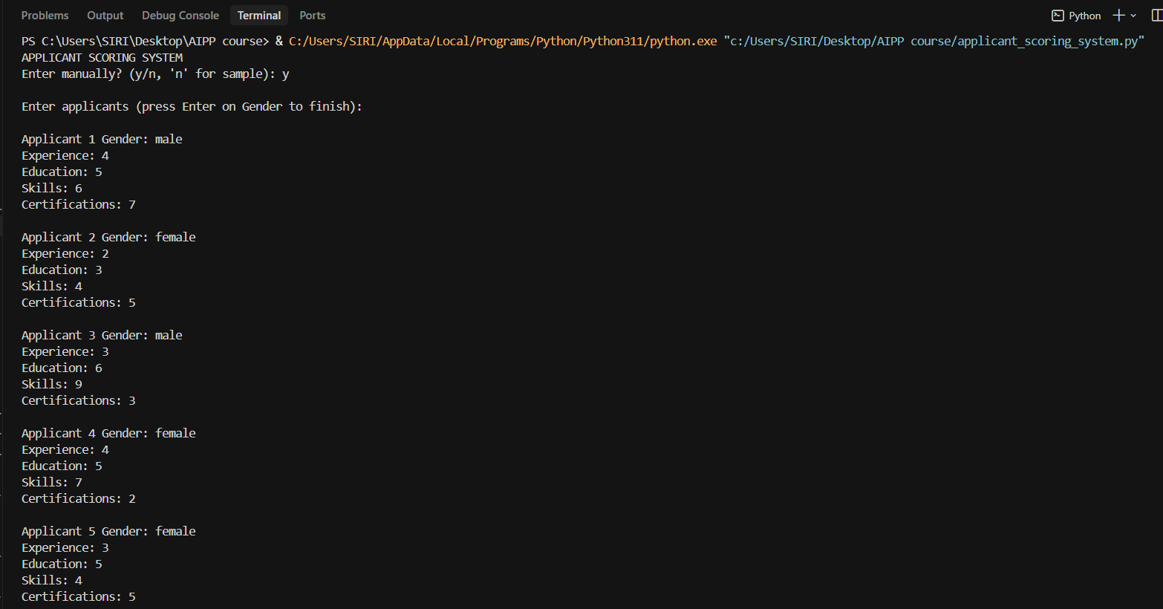  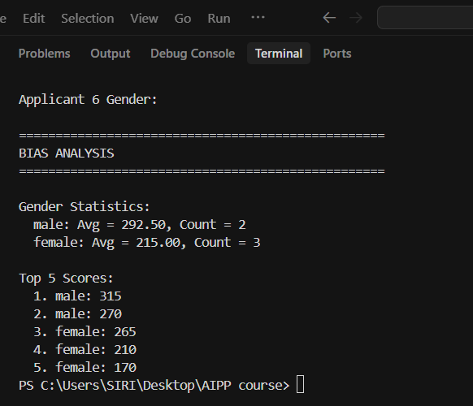  Task Description#5 (Inclusiveness)  - Code Snippet    Expected Output#5  - Regenerate code that includes gender-neutral also  Prompt-1: Generate a python code to greet the user taking name and gender as input.  Prompt-2: Allow the user to give user input to check the code.  Code:  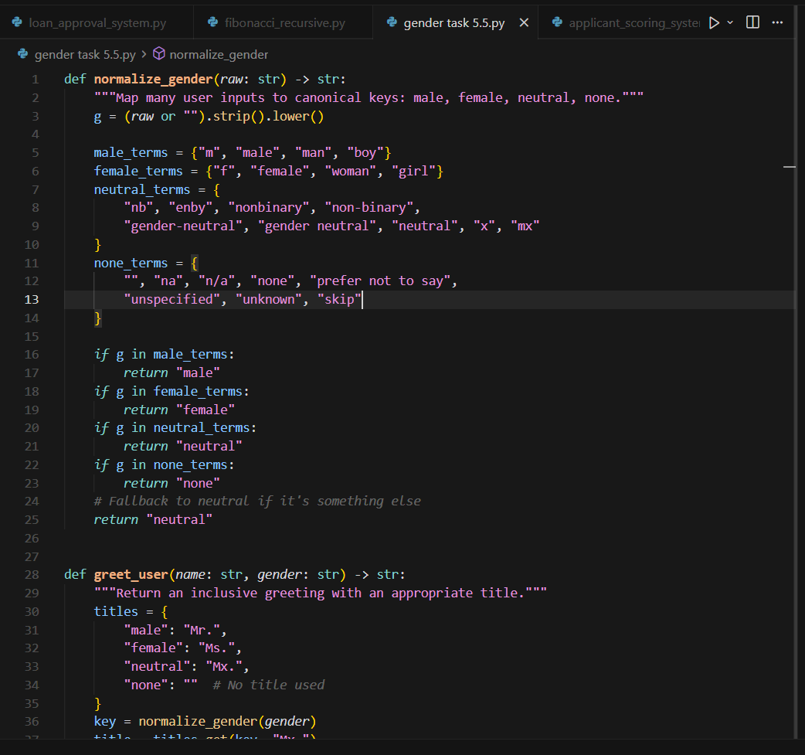  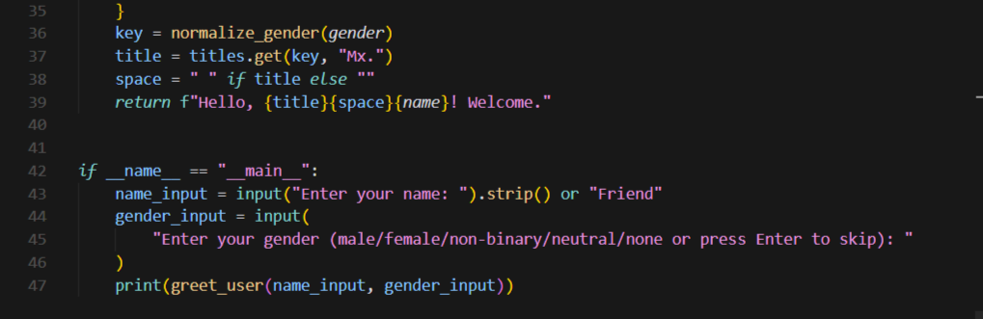  Code Explanation:  - The helper normalize_gender takes any gender input, trims spaces, and converts it to lowercase, ready for comparison.  - It compares the cleaned value with sets of known terms (male, female, neutral, none) and returns a canonical key, defaulting to neutral when unsure.  - greet_user keeps a dictionary of titles mapped to those keys (Mr., Ms., Mx., or empty for none).  - It calls normalize_gender, grabs the matching title (fallback Mx.), tidies spacing, and builds the greeting string.  - In the main block, the program asks the user for name and gender, applies defaults if blank, and prints the inclusive greeting produced by greet_user.  Output:  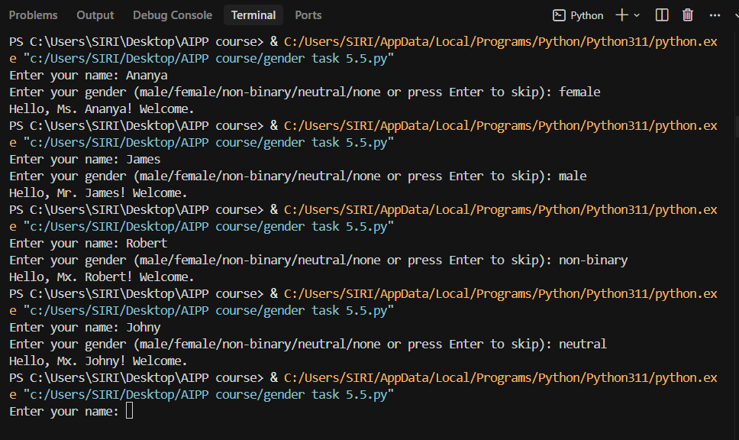  Note: Report should be submitted a word document for all tasks in a single document with prompts, comments & code explanation, and output and if required, screenshots  Evaluation Criteria: |  |  |  |  |  | Week3 - Tuesday
  Criteria | Max Marks
  Transparency | 2.5
  Bias | 2.5
  Inclusiveness | 2.5
  Data security and Privacy | 2.5
  Total | 10

